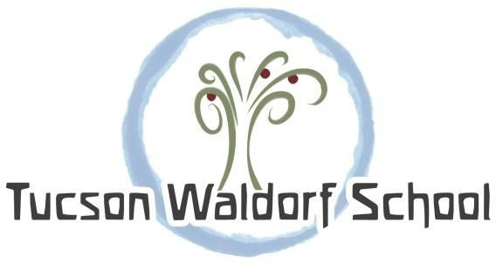

2020 Sponsorship Letter

Tucson Waldorf School (TWS) is a community dedicated to joy in learning. We believe in engaging each child through meaningful experiences, attuned to the unique stages of childhood. Because we are a tuition-based school, we do not receive government funding. As such, we rely on charitable giving to bridge the gap between what tuition covers and the true cost of operating our school.
fresh! is our adults-only, annual spring fundraiser, which provides an opportunity for parents, teachers, and community members to come together in a relaxed and fun environment, right here on the TWS campus, all while raising money to benefit Tucson Waldorf School! You don’t want to miss it!
In addition, this year's theme will include carnival games, a tarot card reader, Sonoran hot dogs, cotton candy, and more surprises! Bid on specialty-themed auction baskets and cap the evening off with dancing. Be sure to bring your poker face for the live auction, then cut loose in the photo booth, wearing your best smiles and some silly props. It’s a night of joyful celebration, candlelight, and laughter under the stars that you'll remember for years to come.
Last year’s event was a huge success! Over 225 guests selected from approximately 80 themed baskets featuring goods and services from many local businesses and partners like Mercado San Augustine, Jen’s Organic Home, Presta Coffee, Sand Reckoner Vineyards, and 1055 Brewing Company. The money raised has enriched our specialty programs, such as orchestra and Spanish, and allowed volunteers to build much-needed play and shade structures and workspaces for our students.

If you have been waiting for the right time to donate, this is definitely the year to be involved.

Sponsoring this wonderful event is a great way to demonstrate your generosity and promote your business! TWS is a 501c(3) nonprofit organization so your donation is fully tax deductible to the extent allowed by law.

We look forward to a long and mutually rewarding relationship. Thank you for your consideration.

In Gratitude,
Melissa Campbell
Development Director
520.529.1032 ext. 1055 or development@tucsonwaldorf.org

3605 E. River Rd. Tucson, AZ 85718 | 520.529.1032 | www.tucsonwaldorf.org | Tax ID# 86-0729122

